WOODLANDS
Medical Centre

Woodlands Medical Centre
1 Greenfarm Road,
Ely,
Cardiff.
CF5 4RG
Tel: 029 2059 1444

www.woodlands-medical-centre.co.uk

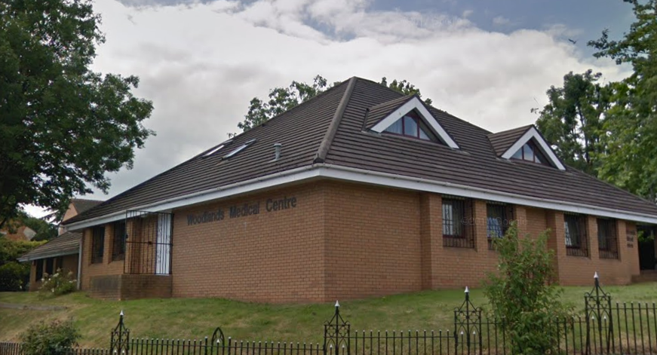

August 2024
Woodlands Medical Centre is a non-limited partnership that provides a full range of high-quality health care services for the whole family.

Our Practice Mission Statement is ‘Health and wellbeing for all who live in our community’.

Our Practice Values are:

- We are kind and caring – we are welcoming, put people at ease, value other people’s time and are compassionate
- We are respectful – we are understanding, attentive, helpful and appreciative
- We trust and act with integrity – we listen, have clear communication, work as a team and speak up
- We take personal responsibility – we are positive and professional. We excel in all we do and strive to keep improving.

Partners
- Dr Debajit Das MBBCh, MRCGP
- Dr Sarah Davies MBBCh, MRCP, MRCGP, DRSH, LoC SDI, LoC IUD, Dip Diabetes
- Dr Rachel Lee MBchB, MRCP, MRCGP, MFHOM, Dip of Palliative Medicine
- Dr Lisa Palmer MBBCh, MRCGP
- Dr Sarah Wynn-Jones MBBS, MRCGP, DRCOG, DCH, DFSRH
- Dr Bronwen Williams MBChB, MRCGP, DGM, DCH, DFSRH

Salaried GP’s
- Dr April Rowntree MBBCh, MRCGP
- Dr Alice Wall MBBCh, MRCGP

Nursing Staff
- Ceri Tanhai (Practice Nurse) BSc RGN
- Sally Pugsley (Practice Nurse) BN
- Lauren Meyrick (Practice Nurse) BN
- Helen Trigg (Health Care Assistant)
- Justine Guy (Health Care Assistant)

Surgery Hours

Monday 8.00-18.30
Tuesday 8.00-18.30
Wednesday 8.00-18.30
Thursday 8.00-18.30
Friday 8.00-18.30

Closed on Saturday and Sundays and Bank Holidays

Woodlands Medical Centre has suitable access for wheelchair users and is equipped with a portable hearing loop.

Registering As A Patient

The practice boundary covers Ely, Caerau, Culverhouse Cross, Wenvoe, Bonvilston, Pendoylan, Peterston-Super-Ely, St Brides-Super-Ely, and some parts of St. Fagans

We welcome registrations from patients moving into the practice area. Please ask at reception for a GMS1 form and patient registration form. You will need to provide your NHS number wherever possible which can be obtained from your NHS medical card or your previous surgery.

Change of Address/Contact Details

Please ensure that you keep us up to date with any changes to your address or contact telephone numbers. We regret that should you move outside of our practice boundary, we will be unable to keep you registered at the practice.

Appointments

You can request an "on the day" urgent appointment every day.
Please Note: On the Day emergency appointments are for urgent matters which you feel cannot wait for a routine appointment.

All urgent appointment requests are triaged by a GP. You will get a phone call back from a GP, and then the necessary course of action will be taken from there. This will be dealt with by the doctor on call, who may not be the doctor of your choice. Wherever possible your right to be seen by a practitioner of your choice will be honoured.

Routine Appointments

Please ring any time to book a routine appointment with the doctor of your choice, or book through our practice website using eConsult. eConsult is an online platform that can be used to request non-urgent clinical advice or administrative help.

House Calls/Home Visits

All house calls are booked through the GP. For a house call, you will initially be booked in for a telephone consultation with a GP and then the appropriate course of action followed. No patient in need of a home visit will be refused, however wherever possible if you can get to surgery, it is more advantageous as we are able to offer a higher quality of care with access to your complete medical records and diagnostic equipment.

Consultations

Patients between the ages of 16-74 who have not been seen at the surgery for a period of 3 years may request a consultation with the GP to discuss any concerns. Consultations can also be requested by patients over the age of 75 who have not been seen at the surgery in the previous 12 months. These appointments may take place in the home of the patient as clinically appropriate. These consultations will be booked as routine appointments and not as urgent appointments.

Cancellations

It is the responsibility of the patient to keep their appointment. If you are unable to attend an appointment, please ensure that you cancel as soon as possible to allow us the opportunity to book another patient into the slot.

Out Of Hours/When We Are Closed

In case of an emergency arising when the surgery is closed, please ring 111. This is a free service provided by Cardiff and Vale UHB, that also offers health information and advice when we are closed. Advice can also be obtained from NHS Direct website www.111.wales.nhs.uk. If you have a medical emergency, a critical or life-threatening problem at any time please call 999.

The dental emergency helpline is 0300 1020247

The out of hours arrangements are not provided by the practice. The local health board is responsible for commissioning the services.

Cardiff and Vale University Health Board
Woodland House
Maes Y Coed Road
Llanishen
Cardiff.
CF14 4TT

Tel. 02920 747747

Test Results

Wherever possible, please telephone after 2pm for test results. Please note that we cannot give information to another person without your written permission. All test results are seen by a doctor and if it is necessary for you to see a doctor for further tests or onward referral you will be offered an appointment when you contact us for your results.

Repeat Prescriptions

Repeat prescriptions requests can be made:
- In person using the box provided in reception and outside when we are closed
- By post. Please enclose an SAE if you would like us to mail your prescription back to you.
- By email to receptionteam.w97023@wales.nhs.uk
- Via the NHS Wales App – please speak to the reception team of visit our website for more information
- Via the chemist (if set up).

Please indicate clearly which items you require by ticking the box next to the item you require on the tear off section of your previous prescription. Please do not request items that you do not need. Please allow three working days for all repeat prescription requests and please make it clear if you would like a prescription to go to a pharmacy. For safety reasons, we do not accept prescription requests over the telephone.

Wherever possible and safe to do so we prescribe 2 months of medication on each prescription.

GP Registrar Training

Woodlands Medical Centre is proud to be a training Practice for General Practitioners. We train clinicians who are already qualified Doctors and are working with us as part of their vocational training to become independent GPs.

Medical Students

The practice does from time to time have medical students for work experience in general practice.
There will be signs up on the day to inform you of medical students with Doctors. If you have any issues about having a medical student in your consultation, please do not hesitate to let a member of staff know.

Clinics/Services We Provide

We provide the following clinics and services in addition to General Medical Services; please ask at reception for more information.

- Maternity  - Ante-Natal  - Baby Clinic / Immunisation  - Chronic Disease Care  - Flu Vaccines | - Contraception  - Minor Surgery  - Cervical Screening  - Travel vaccinations  - Phlebotomy

Fees for Non-NHS Services

Not all services at the practice are available under the NHS. Where patients request non-NHS services, a private fee may be payable in accordance with British Medical Association (BMA) guidance and in line with charges applied by other General Practice surgeries. Fees & charges for these services are shown below and are payable in advance.

Payment is by card, cash or cheque (made payable to Woodlands Medical Centre)

All fees are payable in advance.
All fees are a guide and may be subject to adjustment for complex work.
We aim to complete work within 28 days.

Certificates & Forms

“To Whom It May Concern” Letter............................................................................... £35 Private Certificate of Sickness....................................................................................£35 Fitness to Travel Certificate (without examination).....................................................£35 Fitness to Travel Certificate (with examination)..........................................................£75 Holiday Cancellation Certificate……………………………………………….................£35 Private Healthcare Insurance Form…………………………………………................£35 Certificate of Fitness…...................................................................................................£35 Legal Aid Letter…………….………................................................ ....................................... £35
DS1500 Form…………………………...………………………… ………….….………..……£17
School Fees Insurance Claim……………………..………………………… . ………. ……£35
Freedom From Infection Certificate………………………………… ……………..……….…£35
Slimming Club/Health Club Certificate/Questionnaire……………..………………… …….…£35
Travel Concession Forms (e.g. bus pass form)……………… ………………………… …….£15
Water Sure Form……………………………………… …………………………………………£15

Medical Examinations and Reports

Firearms License……................................................................................................£75 Insurance Claim Report (no examination).........................................................from £55 Insurance Claim Report (with examination).....................................................from £100 Employers Report (No Examination)..............................................................from £100 Employers Report (With Examination).......................... ..............................................from £150
Accident & Sickness Insurance (Full Examination & Report)............................................... £150
Pre-Employment Medical (Up To 45 Minutes) .................................................................... £100
LGV/PCV Examination – Local Authority ............................................................................ £100
HGV/PSV Medical (30 – 45 Minutes)......................................................................... £100 Elderly / Racing Car Fitness (30 – 45 Minutes).................................................................. £100
Taxi Driving Fitness With Medical On Provided Form........................................................ £100
Medical Fitness Examination /Statement For Registered Body (no examination)………......£55
Medical Fitness Examination /Statement For Registered Body (with examination)………. £110
DVLA (No Examination)................................................................................................ £40 DVLA (With Examination)............................................................................ …………...........£85
Photocopies, Per Sheet................................................................................................... ..£0.35

Others

Medical Certificate Court Of Protection ................................................................... £150 Childminder Health Form..........................................................................................£55 Children Fitness To Take Part In Musical/TV............................................................£55 Fostering/Adoption Report ..................................................................................£25.58 Fostering/Adoption Medical (VOG)......................................................................£77.07 Fostering/Adoption Medical (private not VOG)............................................................. £80 Power Of Attorney (No Examination)..............................................................P.O.A. (from £150) Power Of Attorney (With Examination).................................................P.O.A. (from £250) Private Patient Consultation................................................................................................£110
Private Sick Note.........................................................................................................£35 Private Prescription (non registered patients only) ................................................................£35

Zero Tolerance Policy

As a practice we aim to treat all patients with dignity and respect. We have the right to expect the same from our patients.

We have a zero tolerance policy regarding aggressive behaviour or abuse to any member of staff or visitor to the practice. This includes the use of offensive and foul language.
Patients who behave in this manner will be removed from the practice list.

Complaints/Feedback

We operate a practice complaints procedure as part of the NHS Putting Things Right system for dealing with complaints. If you have any comments or criticisms of the service you have received from this surgery, please write to our Practice Manager, Claire Walker at the surgery, or by email to practice.manager.w97023@wales.nhs.uk.

If you feel that you cannot raise your complaint with us, or if you are dissatisfied with the result of our response, you can contact Cardiff and Vale University Health Board Concerns Team on 02921 836 318. You can also email the team at concerns@wales.nhs.uk or write to the Chief Executive, Cardiff and Vale University Health Board, Maes y Coed Road, Cardiff CF14 4HH.

More information can be found on their website. www.cavuhb.nhs.wales/patient-advice/concerns-complaints-and-compliments/concerns-complaints/

Patient Privacy

Woodlands Medical Centre is classed as a Data Controller for the Purposes of Data Protection and our registration number with the Data Protection Public Register is Z7844949. The practice is committed to protecting your personal information and respecting your privacy. We have a legal duty to explain how we use personal information about you as a registered patient at the practice.

What Information do we collect about you?
We will collect information about you and in relation to your health and health care services you have received. This will include personal information such as your NHS number, name, address, contact information, date of birth, and next of kin.

We will also collect sensitive personal information about you (also known as special category data) which includes information relating to your health (appointment visits, treatments information, test results, X-rays or reports), as well as information relating to your sexual orientation, race or religion.

All the above information we collect and hold about you forms part of your medical record and is primarily held to ensure you receive the best possible care and treatment.
We may also collect your personal image on surgery CCTV when you attend the practice premises.

Please see our website www.woodlands-medical-centre.co.uk for our full Privacy Notice.

Welsh Language Duties

All documents provided by the local health board will be available in Welsh language versions. All new signs or notices will be bilingual and your language preference will be recorded on your medical records.

LHB Address

Cardiff and Vale UHB,
Woodland House
Maes Y Coed Road
Llanishen
Cardiff.
CF14 4TT

Tel. 02920 747747
Cav.primaycare@wales.nhs.uk

